Occoneechee Lodge Planbook Program C-1

 | 2025 | 2026 | 2027
**Carolina’s Indian Seminar | January 24-26 | TBD | TBD
Spring Pow-Wow | March 14-16 | March 20-22 | March 19-21
Executive Committee Meeting | March 16 | March 22 | March 21
**National Leadership Seminar  (NLS / DYLC)  (Eastern Region Dates Listed) | February 7-9  March 21-23  October 3-5  December 5-7 | TBD | TBD
E8 Conclave | April 11-13 | April 17-19 | April 16-18
Spring Inductions | May 16-18 | May 15-17 | May 14-16
Executive Committee Meeting | May 18 | May 17 | May 16
**Camp Durant Summer Camp Staff Week | June 6-11 | TBD | TBD
**Summer Camp Weeks | June 15 - July 12 | TBD | TBD
**Cub Scout Adventure Camp | June 12-14 | TBD | TBD
**National Jamboree |  | July 22-31
**National OA Conference (NOAC)
Trade-o-Ree / Gentgeen | August 15-16 | August 14-15 | August 20-21
Fall Fellowship | September 19-21 | September 18-20 | September 17-19
Executive Committee Meeting | September 21 | September 20 | September 19
Lodge Officer / Adviser Retreat (LOAR) | October 10-12 | October 9-11 | October 8-10
Vigil Gathering | October 18-19 | October 17-18 | October 16-17
Lodge Leadership Development | November 14-15 | November 13-14 | November 19-20
Executive Committee Meeting | November 15 | November 14 | November 20
Winter Banquet | December 6 | December 5 | December 4
Executive Committee Meeting | December 6 | December 5 | December 4

*Lodge policy is that if the Patch Committee utilizes a youth designed patch for a Lodge event, the youth designer attends the event without charge. All Lodge event patch selections are determined and approved by the Lodge Executive Committee. All Lodge event patch designs are due to the Patch Committee before the Executive Committee Meeting.

** Camp Durant Information: www.campdurant.com
** OA National Calendar: https://oa-scouting.org/program/national-calendar
** NLS / DYLC Information: https://oa-scouting.org/training/national-leadership-seminar-nls
** OAHA Information: https://oa-scouting.org/high-adventure
** The Summit Bechtel Reserve http://www.summitbsa.org/
** National Jamboree: https://jamboree.scouting.org/
** Carolina’s Indian Seminar Contact: https://eswau.net/contact-us/contact-us-about-cis/

Occoneechee Lodge Planbook Program C-2

TIPI (Lodge Newsletter)

 | 2024 | 2025
Tipi Articles Due (Winter) | February 15 | February 15
Tipi Articles Due (Spring) | May 15 | May 15
Tipi Articles Due (Summer) | August 15 | August 15
Tipi Articles Due (Fall) | November 15 | November 15

Tipi article due dates are set to ensure the Tipi is published two weeks prior to a Lodge scheduled event except for Winter Banquet which is provided at the event. The Winter Tipi is a historical review of the past year and introduction articles from the incoming Lodge Officers and Advisers for the coming New Year. Special two-page Tipi editions may be published during each of the weekend Lodge events as requested by the Lodge Chief.

Individual Event Information

 | Ordeal | Brotherhood | Training | Service | Activity Features
Spring Pow-Wow |  | Brotherhood Trail | AIA  Nimats,  OA reps,  etc | Yes | Quest, AIA competitions, Lodge Pow Wow,  Prep for Conclave, WEBELOS OA event;  Vigil and Founders Award Nominations Due
E8 Conclave |  |  | OAX | Yes | Exhibits, Council of Chiefs Meeting, Founders Award
Spring Inductions | Inductions |  | OA reps | Yes | Camp Wide Service Projects
Fall Fellowship | Inductions | Brotherhood Trail | OA reps | Yes | Lodge Officer Elections, Annual Award  Petitions Due, Vigil Call-Out Ceremony
Vigil Gathering |  |  |  |  | Vigil Inductions
Lodge Leadership Development |  |  | Officer Training,  OA reps |  | Executive Committee Meeting,  Establish Lodge Goals
Winter Banquet |  |  |  |  | Silent Auction, Catered Meal, Annual  Lodge Award Presentations

Attendance Fees and Descriptions
 | Total Event Fee | Included Items:
Standard Event Fee | $25 | Event patch, Meals, Cracker-barrel
Winter Banquet Fee | $25 | Banquet Meal, Event Patch
The following fees are total amounts and include the Standard Event Fee
Ordeal Candidate Fee | $50 | Standard Event Fee Items plus: Ordeal sash, Ordeal flap, annual dues
Brotherhood Candidate Fee | $25 | Candidates Pay Standard Event Fee; Includes Standard Event Items plus: Brotherhood sash, Brotherhood flap. Brothers converting to Brotherhood during Camp Durant Summer Camp do not pay an event fee.
Elangomat Fee | $25 | Standard Event Fee Items plus: Elangomat Patch and T-shirt
Late Registration fee is in addition to other event fees stated above
Late Registration Fee | $10 | A late registration fee of $10.00 will be charged for those whom  have not paid and registered at least 7 days prior to any Lodge  event.

Occoneechee Lodge Planbook Program C-3

Lodge Event Attendance
Please note LLD and Winter Banquet Numbers are from Previous Year (I.e. 2021 WB numbers are from December 2020)
 |  | 2015 | 2016 | 2017 | 2018 | 2019 | 2020 | 2021 | 2022 | 2023 | 2024 | 2025
LLD | TOTAL | 119 | 83 | 93 | 70 | 79 | 81 | 79 | 95 | 109 | 106 | 108
Winter Banquet | TOTAL | See Fall Gathering | 288 | 238 | 192 | 189 | 191 | 6 | 191 | 216 | 222 | 311
Spring Pow-Wow | TOTAL | 535 | 352 | 309 | 255 | 477 |  | 357 | 216 | 280 | 277
Spring Pow-Wow | Brotherhood | 88 | 101 | 77 | 57 | 17 |  |  | 85 | 104 | 72
Spring Pow-Wow | Ordeal | 174 |  |  |  | 186 |  | 163
Spring  Inductions | TOTAL | 511 | 662 | 653 | 488 | 335 |  | 181 | 341 | 453 | 448
Spring  Inductions | Brothers | 318 | 332 | 358 | 257 | 226 |  | 87 | 187 | 253 | 254
Spring  Inductions | Ordeal | 193 | 330 | 295 | 230 | 108 |  | 94 | 154 | 200 | 194
Spring  Inductions | Youth | 341 | 463 | 450 | 330 | 224 |  | 121 | 216 | 292 | 289
Spring  Inductions | Adults | 170 | 199 | 203 | 158 | 111 |  | 60 | 125 | 161 | 159
Spring  Inductions | Brotherhood | 38
Fall  Fellowship | TOTAL | 556 | 643 | 559 | 435 | 366 | 324 | 403 | 391 | 414 | 444
Fall  Fellowship | Brothers | 397 | 466 | 405 | 348 | 315 | 180 | 281 | 284 | 316 | 339
Fall  Fellowship | Ordeal | 159 | 177 | 154 | 86 | 50 | 144 | 122 | 107 | 98 | 105
Fall  Fellowship | Youth | 365 | 420 | 356 | 267 | 237 | 187 | 248 | 235 | 255 | 262
Fall  Fellowship | Adults | 191 | 223 | 203 | 166 | 128 | 137 | 155 | 156 | 159 | 182
Fall  Fellowship | Brotherhood | 36 | 86 | 59 | 32 | 72 |  | 17 | 32 | 14 | 21
Fall Gathering | TOTAL | 226
Banquet | TOTAL | 243
Vigil Honor | TOTAL | 24 | 16 | 20 | 14 | 21 | 11 | 17 | 11 | 20 | 25
Vigil Honor | Youth | 12 | 8 | 11 | 6 | 12 | 7 | 8 | 4 | 12 | 12
Vigil Honor | Adults | 12 | 8 | 9 | 8 | 9 | 4 | 9 | 7 | 8 | 13
Membership | TOTAL | 1916 | 1917 | 1935 | 1706 | 1829 | 1241 | 1333 | 1271 | 1276

Occoneechee Lodge Planbook Program C-3

Section / Region / National Event Attendance

Event |  | 2015 | 2016 | 2017 | 2018 | 2019 | 2020 | 2021 | 2022 | 2023 | 2024 | 2025
CONCLAVE | TOTAL | 455 | 395 | 348 | 274 | 594 |  | 62 | 122 | 134 | 159
CONCLAVE | Y/A | 288/157 | 243/152 | 215/133 | 171/103 | 360/233 |  | 29/33 | 51/71 | 68/66 | 91/68
NOAC | TOTAL | 108 |  |  | 40 |  | 35 |  | 52 |  | 20
NOAC | Y/A | 79/29 |  |  | 29/11 |  | 23/12 |  | 30/22 |  | 14/6
NEXT | TOTAL |  | 5
NEXT | Y/A |  | 3/2
NLS/  DYLC | TOTAL | 8 | 6 | No Data |  |  |  |  |  |  | 3
NLS/  DYLC | Y/A | 4/4 | 4/2 |  |  |  |  |  |  |  | 2/1
PRISM | TOTAL |  | 17
PRISM | Y/A |  | 9/8
Operation Arrow | TOTAL |  |  |  |  |  |  |  |  | 1
Operation Arrow | Y/A |  |  |  |  |  |  |  |  | 1/0

Arrowmen's Duty to Their Unit

The Order of the Arrow is principally a young man's organization, and the most important role of the adult advisers is to keep the leadership in the hands of the youth.

An Arrowman's primary duty is to the unit which elected them into the Order, and to promote
active participation of a unit's Order of the Arrow membership in the development of the unit's
outdoor and camping activities, thereby strengthening the unit's program. Duties include:

- Being active in all unit activities; assuming a leadership role.
- Assisting the unit to camp on a regular basis, essentially being the camp promoter of the unit.
- Serving as a role model for exemplary camping.
- Furnishing unit leadership with current camping guide information, that is a "Where To Go Camping" booklet.
- Making certain the Lodge Camping Promotion Team visits their unit during the year.
- Making certain that the unit holds its annual Order of the Arrow election; encouraging the Ordeal candidates to come do their Ordeal.
- Encouraging the unit to assist the lodge and council in a wide variety of camp, council, and community service projects.
- Keeping other Arrowmen in the unit informed of important Lodge and Council happenings.
- Best exemplifying the Scout Oath and Law in daily life.
- Assisting the unit leadership.
- Wearing the Scout uniform properly.
Occoneechee Lodge Planbook Program C-4

Adult/Adviser Responsibilities

The role of the Order of the Arrow adviser is to enhance the general manner in which an adult in this capacity can support the youth of the lodge.

Some of the roles and responsibilities of an adviser are:

- KEEPING THE LEADERSHIP IN THE HANDS OF THE YOUTH
- The position responsibilities of a chapter, lodge, section or staff adviser
- A means of transportation for the youth leadership
- Functioning as adult Order of the Arrow Coordinator with unit adults
- Serving as a non-voting member of the Order of the Arrow Lodge Executive Committee
- Recruiting for, and possibly assuming responsibility for, training events
- Coordinating with other adult Arrowmen
- Serving as committee advisers for youth and adults
- Acting as an informal trainer of officers
- Being a sounding board for concepts and ideas
- Being a source of new ideas
- Being a resource person for the officers
- Evaluation of proposals relative to BSA and Order of the Arrow policy and procedures
- Enthusiastically supporting the young men and women of the Lodge
- Counseling and supporting the other adult Arrowmen working with the youth

Occoneechee Lodge Planbook Program C-5

Effective Chapter Meetings

- Planning IV. Implementation of the Plan/Program
  - Chapter EC Meetings A. Follow Your Outline
  - Meeting Outline B. Use Your Resources
  - Program C. Vary the Programs
  - Proper Prior Planning Prevents D. Vary the Implementers
Pitifully Poor Performance E. Follow-through
F. Plan the Work - Work the Plan

- Program V. Attendance - How to Get Them There
- Planning Chapter Events & A. Have good Programs
Projects B. Communicate
- Indian Culture C. Involve Everyone
- Brotherhood Counseling D. Have Food
- Elangomat Training E. Use Scoutmasters for
- Committee Meetings & Workshops Transportation (Roundtable)
- Guest Speaker
- Fellowship

III. Communications VI. Evaluation
- Newsletter A. Solicit Input from Everyone
- Word-of-Mouth B. Review the Input
- Calling System C. Use the Input to Make
- Flyers in Unit Meeting Places Improvements
- Scoutmaster Promotion

VII. Some Mechanics
- Opening- Obligation
- Make sure Youth are Leading
- Adviser’s Minute (At the End)
- Closing- Song of the Order
- Keep Them Short (1-2 hours)
- Keep Them Seldom (1 per month, maximum)

Occoneechee Lodge Planbook Program C-6

National, Regional, Section, Council & Lodge Order of the Arrow Structure

National Executive Board & National Committee Occoneechee Council
National Order of the Arrow Committee Occoneechee Lodge 104
Eastern Region Occoneechee Lodge Executive Committee (LEC)
Section 8 Occoneechee Lodge Chapters
Occoneechee Members

National, Regional, and Section E8 Activities

October Council of Chiefs
This is a meeting of all members of the Council of Chiefs, and all Lodges should be represented. At this meeting all the unfinished business will be finalized and the final preparations for the Cardinal Conclave will be made. This is an important meeting because the Council of Chiefs will not meet again as a group until the Conclave.

Cardinal Conclave
This is a weekend gathering of all lodges in Section E8 for fellowship, training, and spirit development of Scouting and the Order of the Arrow. The Conclave is held at a council camp hosted by a lodge in the Section on a rotating basis. The primary purpose of the Conclave is Training! Also, new Section Officers are elected at this time for the upcoming year.

National Order of the Arrow Conference
Every other year, a National OA Conference is held on the campus of a college somewhere in the United States. Training and fellowship is a large portion of its program with Arrowmen from all over the nation participating. The program is planned and executed by Arrowmen under 21 years of age. Each Lodge in the Section should send delegates to the conference to benefit from all it has to offer.

Lodges in Section E8, their Councils, & Conclave Schedule

 | Lodge | Camp | Council
2025 | #70 Tsoitsi Tsogali’i  www.lodge70.org | Camp Cherokee  https://www.csr.camp/ | Old North State Council, Scouting America  #418 1405 Westover Terrace  Greensboro, NC 27408  (336) 378-9166 / (800) 367-9166  https://bsaonsc.org/
2026 | #104 Occoneechee  www.lodge104.net | Camp Durant  https://ocscouts.org/ | Occoneechee Council, Scouting America #421 PO Box 41229  Raleigh, NC 27269-1229  (910) 872-4884 / (800) 662-7102  https://ocscouts.org/
2027 | #331 Klahican  www.klahican.org | Camp Bowers  https://www.capefearcouncilbsa.org/camping/camp-bowers/ | Cape Fear Council, BSA  PO Box 7156  Wilmington, NC 28406  910-395-1100  https://www.capefearcouncilbsa.org/
2028 | #296 Nyawin Rar  https://sites.google.com/site/nayawinrar296/home?authuser=0 | Camp Tuscarora  https://www.tuscarorabsa.org/camptuscarora | Tuscarora Council, BSA  # 424 Box 1436  Goldsboro, NC 27530  (919) 734-1714  https://tuscarorabsa.org/
2029 | #117 Croatan  www.croatan.org | Camp Boddie  https://www.eccbsa.org/camping/camp-boddie/ | East Carolina Council, BSA #  426 PO Box 1698  Kinston, NC. 28501  (252) 522-1521  https://www.eccbsa.org/
2030 | #118 Wahissa  www.wahissa.org | Camp Raven Knob  https://www.ravenknob.com/ | Old Hickory Council, Scouting America  # 427 6600 Silas Creek  Parkway Winston Salem,  NC 27106 (336) 760-2900  www.oldhickorycouncil.org

Occoneechee Lodge Planbook Program C-7

Camp Durant Site Assignments

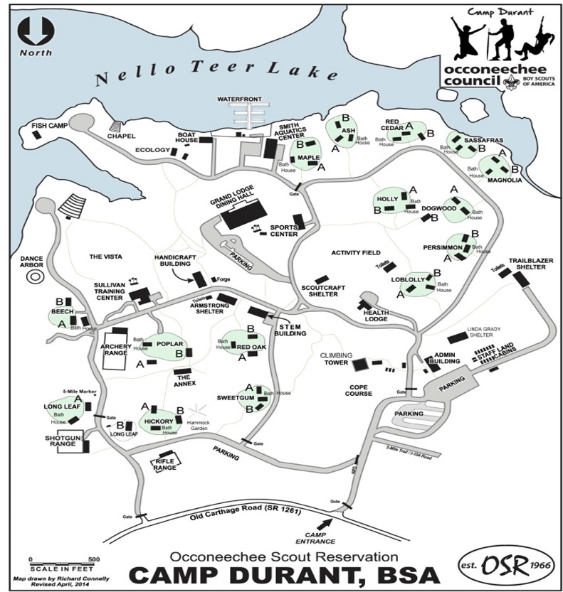

Site Name | Chapter | District
Ash | Ilau Machque | Cardinal
Red Cedar / Holy | Netopalis | Sandhills / Eno River
Maple | Kiowa | North Star
Red Oak | Netami | Cardinal
Hickory | Eluwak | Eno River
Sweetgum | Neusiok | North Star
Loblolly / Persimmon | Saponi | Eno River
Dogwood | Temakwe | Sandhills
Poplar | Mimahuk | Sandhills
Sassafras / Magnolia | Lauchsoheen | Sandhills

